Technical note

Biztalk and SQL Server Design
1010448-13 Noise – Near Real Time data exchange
EEA – European Environment Agency

Project no.: 1010448-13 |  | DOCUMENT REF:  0000.doc
Revision | Description | Written by | Reviewed by | Approved by | Date
0.1 | First draft | MBO  Morten Bødtkjer |  |  | 03.06.2011

Table of Contents

1 Introduction 3
2 The main process 4
The database interfaces 5
2.1 Views (lookup table caching) 5
2.1.1 View_Phenomenon 5
2.1.2 View_Offering 5
2.1.3 View_FeatureOfInterest 5
2.1.4 View_Procedure 6
2.2 Stored procedure for data inserts and updates 6
2.2.1 InsertObservation 6
2.3 Adding new features-of-interests dynamically 6
3 Data mapping 7

Introduction

This document describes the Biztalk and SQL Server design of implementing a NRT (Near Real Time) data exchange system using the already existing IT infrastructure at EEA.

The Biztalk and SQL Server are parts of a pilot implementation towards EEA's NRT data exchange system based on OGC SOS (Sensor Observation Server) principles.

The main process

The main process (the Biztalk orchestration) is illustrated below.

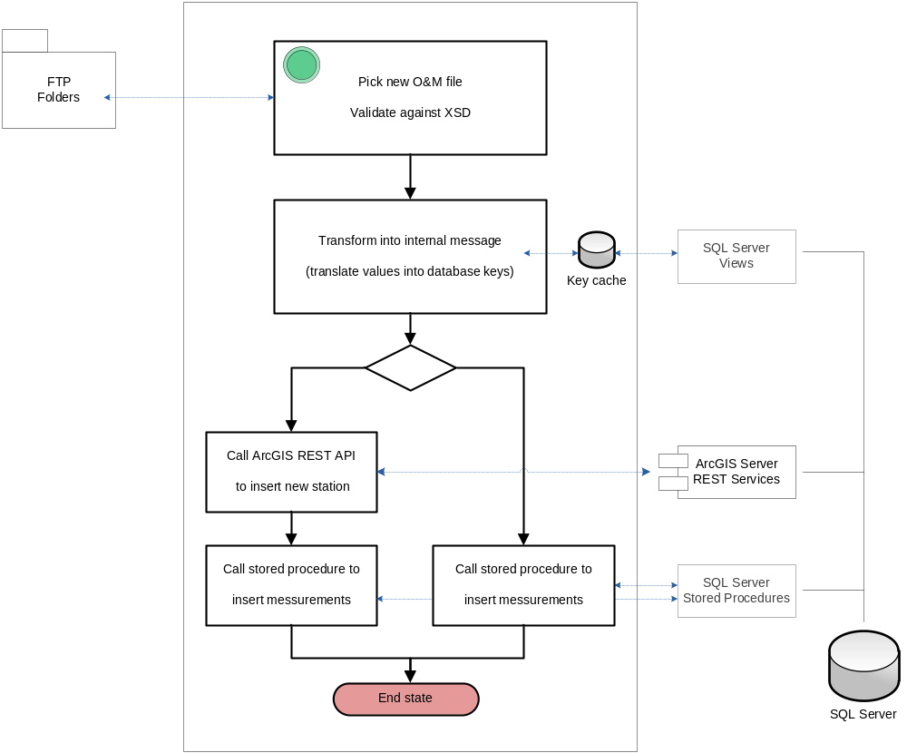

The O&M messages are picked up, parsed, and validated against the XSD schema.

The message is transformed into an internal message. The schema of the internal message is generated from the stored procedure for data insert. (See chapter 4)

During the transformation the type values ("Feature of Interest", "Phenomenon" etc) are translated into database key values. (See chapter 3)

Thus, after the transformation the message will be prepared for the database insertion.

If an O&M message contains a feature-of-interest that is not already registered in the database, Biztalk will invoke an ArcGIS Server REST operation to add it. (See section 3.3)
After that the key value belonging to the new feature-of-interest must be injected into the internal message. Also cache that holds the keys must be updated to include the new key.

Finally a stored procedure is called to insert each observation/measurement in the message. (See section 3.2)

The database interfaces

Views (lookup table caching)
During the transformation of the incoming O&M message into an internal message prepared for database insertion, the reported type values are translated into database key values.

A set of views is created, and cached inside Biztalk as hash tables, in order to make this translation (key lookup) fast.

The views contain values/keys for the different O&M entities like "Offering" and "FeatureOfInterest".
The selects behind the views query the EEA data model. Thus, the mapping between the O&M entities and the EEA data model is implemented using database views.
The views are an abstraction layer upon the data model.

In the following sub sections the views are described.

View_Phenomenon
A phenomenon represents what is being measured. In the EEA data model it corresponds to a component.

CREATE VIEW giseditor.View_Phenomenon
AS
SELECT cCode, pk_component_id
FROM giseditor.component

Notice that the cCode column must contain URN values defined by OCG.

View_Offering
An offering represents what is beeing measured.
No entity in the EEA data model corresponds to an offering.

An "Offering" table/view must be added the EEA database.

CREATE VIEW giseditor.View_Offering
AS
.....

View_FeatureOfInterest
A feature of interest represents a location of a measurement/observation. In the EEA data model it corresponds to a station.

CREATE VIEW giseditor.View_FeatureOfInterest
AS
SELECT sName, pk_station_id
FROM giseditor.station

View_Procedure
A procedure represents the sensor of a measurement/observation.
No entity in the EEA data model corresponds to a procedure.

An "Procedure" table/view must be added the EEA database.

CREATE VIEW giseditor.View_Procudure
AS
.....

Stored procedure for data inserts and updates
To insert or update observations/measurements a stored procedure "InsertObservation" is created

InsertObservation
The procedure with the following header definition must be implemented in the EEA database:
ALTER PROCEDURE giseditor.InsertObservation
@dt datetime,
@value numeric(38,8),
@FeatureOfInterestID uniqueidentifier,
@ProcedureID uniqueidentifier,
@OfferingID uniqueidentifier,
@PhenomenonID uniqueidentifier
AS
...

If a value for the given timestamp, phenomenon, offering, feature of interest, and procedure already exists the value for that row will be updated to the new measurement value.

Adding new features-of-interests dynamically
If an O&M message contains a feature of interests that is not already registered in the database, the system should be able to automatically register it.

A feature of interest holds a location (point geometry), and therefore it cannot be inserted directly into the database. The reason is that EEA uses ArcGIS Server to manage the geospatial data.

However, ArcGIS Server REST services can be used for adding new data

The REST service operation to be used is:
http://help.arcgis.com/en/arcgisserver/10.0/apis/rest/fsadd.html

Data mapping

The data mapping between the O&M format (simplified) and the internal format is described in the chapter.

The structure of the O&M format (simplied) is:
- om:ObservationCollection
  - om:member
    - om:Observation
      - om:samplingTime
      - om:procedure
      - om:observedProperty
      - om:featureOfInterest
      - om:result
        - swe:dataArray
          - swe:elementCount
          - swe:elementType
          - swe:encoding
          - swe:values

The structure of the internal format will be created by and reflect the structure of the stored procedure to insert measurements, i.e.:
- Record
  - Dt
  - Value
  - FeatureOfInterestID
  - ProcedureID
  - OfferingID
  - PhenomenonID

The Biztalk map should be implemented according to the following rules
- For each <swe:dataArray> a number of <Record> must be created. The number of <Record> to be created equals the value of the <swe:elementCount> element.
- The string inside the <swe:values> element must be split by the block separator (specified by the <swe:encoding> element).
  - Every resulting sub string must be further split by the token separator (specified by the <swe:encoding> element)
  - The start timestamp/date must be mapped to <Dt>
  - The measurement value must be mapped to <Value>
  - The position of the start timestamp and measurement value in the "block" are specified in the <swe:elementType>
- <FeatureOfInterestID> is the database key which belongs to the <gml:name> inside the <om:featureOfInterest>.
The database key is found using a cache functoid which holds data from "view_FeatureOfInterest"
- <ProcedureID> is the database key which belongs to the href attribute in the <om:procedure> element.
The database key is found using a cache functoid which holds data from "view_Procedure"
- <OfferingID> is the database key which belongs to the href attribute of the <om:observedProperty> element
The database key is found using a cache functoid which holds data from "view_Offering"
- <PhenomenonID> is the database key which belongs to the href attribute of the <om:observedProperty> element
The database key is found using a cache functoid which holds data from "view_Phenomenon"

